# Logotipo, nome da empresa Descrição gerada automaticamenteCATÁLOGO DE PNEUS – RM RODAS E PNEUS

MARCAS DIVERSAS

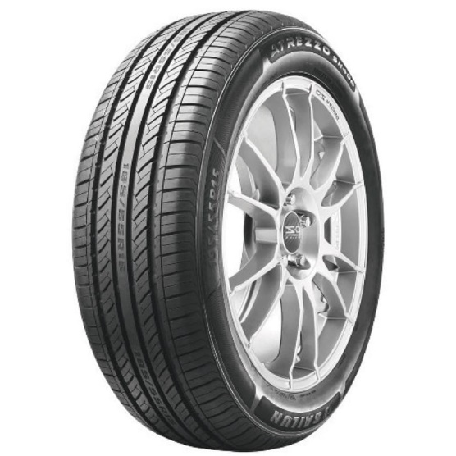

PNEU SAILUN 175/70R14 84T ATREZZO SH406

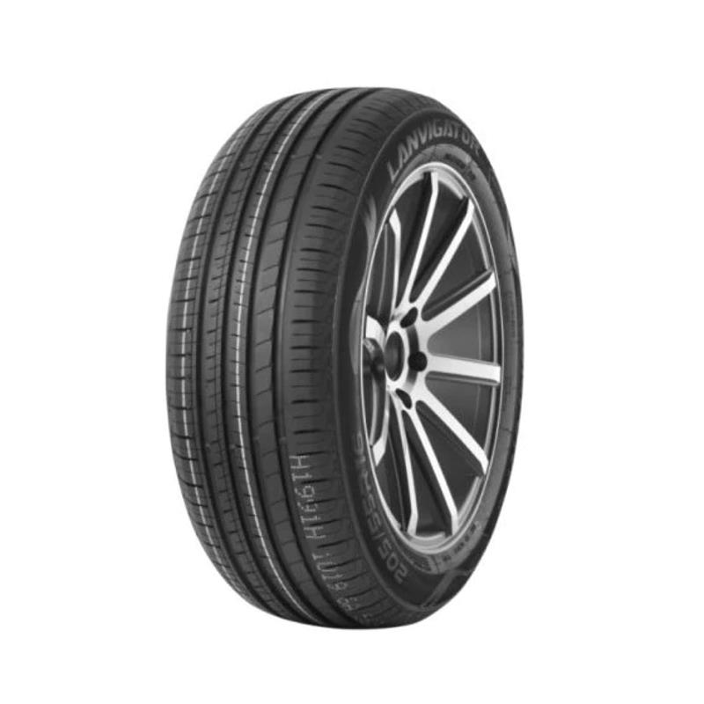

165/70R14 LANVIGATOR COMFORT II 81T

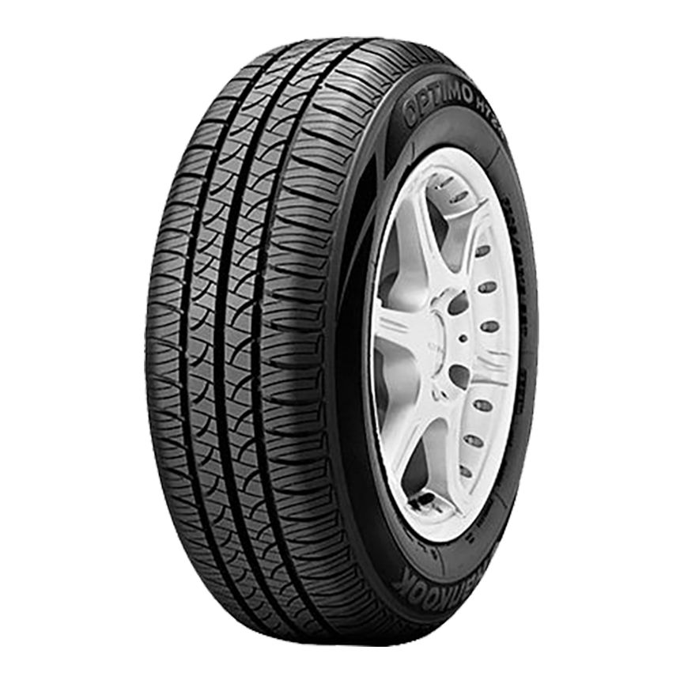

Pneu Hankook Aro 14 175/65R14 Optimo H724 81T

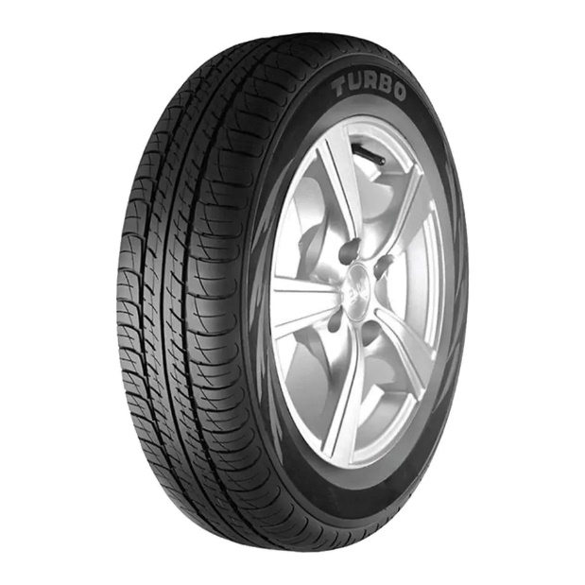

Pneu Aro 13 175/70R13 82T Turbo JK

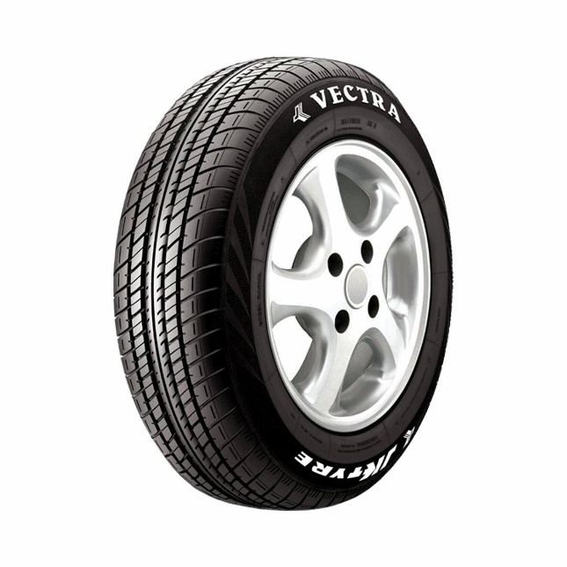

Pneu aro 14 JK Tyres Vectra 175/65R14 PR4 82T T

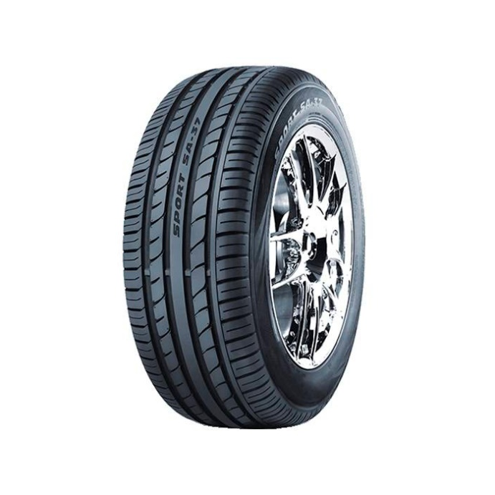

Pneu Westlake 185/35 R17 74V Xl Sa37

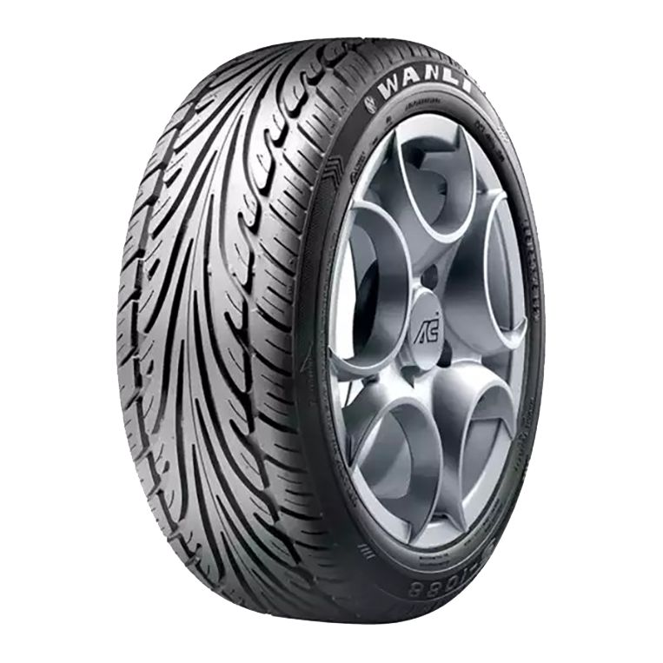

Pneu Wanli Aro 20 275/40R20 S-1088 106W

PICK UP /SUV

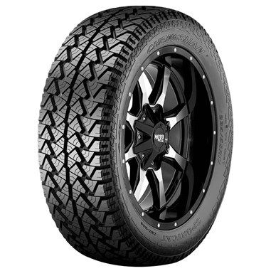

Pneu 235/70R16 Chengshan CSC-302 AT Sportcat 106T

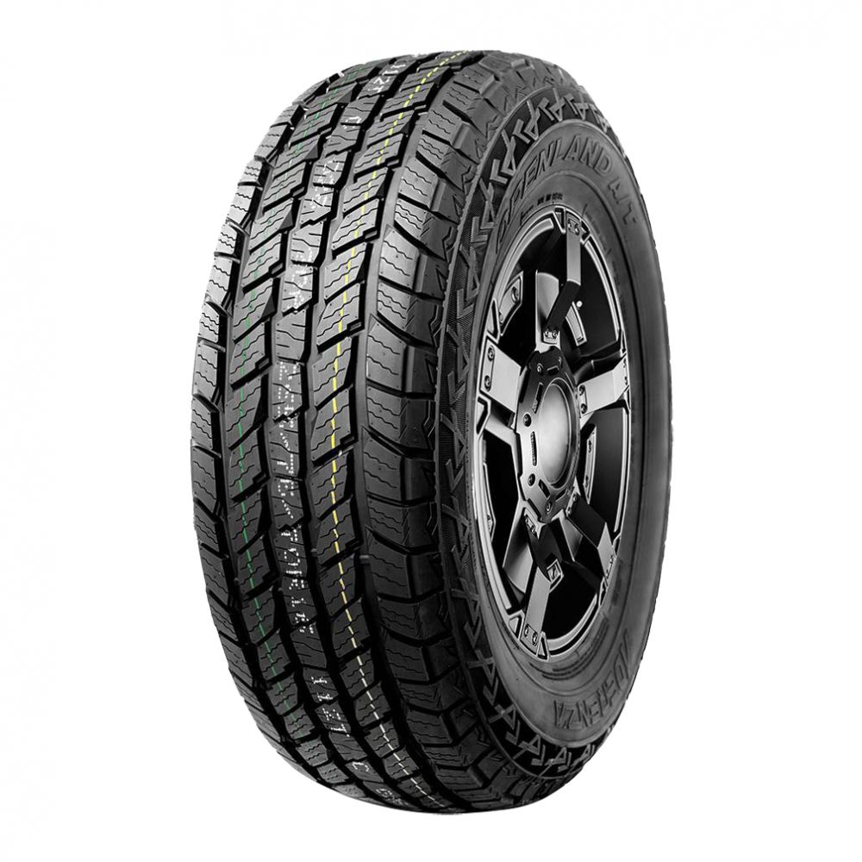

Pneu Aderenza Aro 16 205/60R16 Openland AT D2 92H

VAN

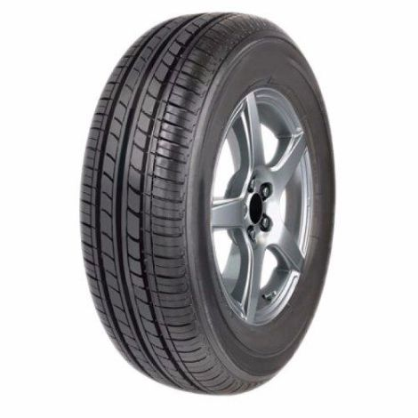

PNEU 165/80R13 83T 109 ROADKING

CARGA

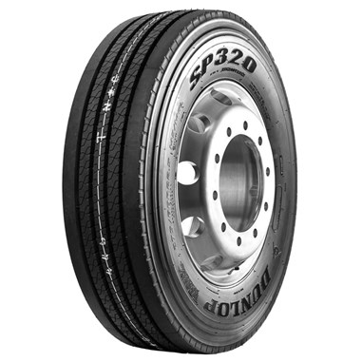

Pneu 215/75R17,5 Dunlop SP320 Liso 126/124M

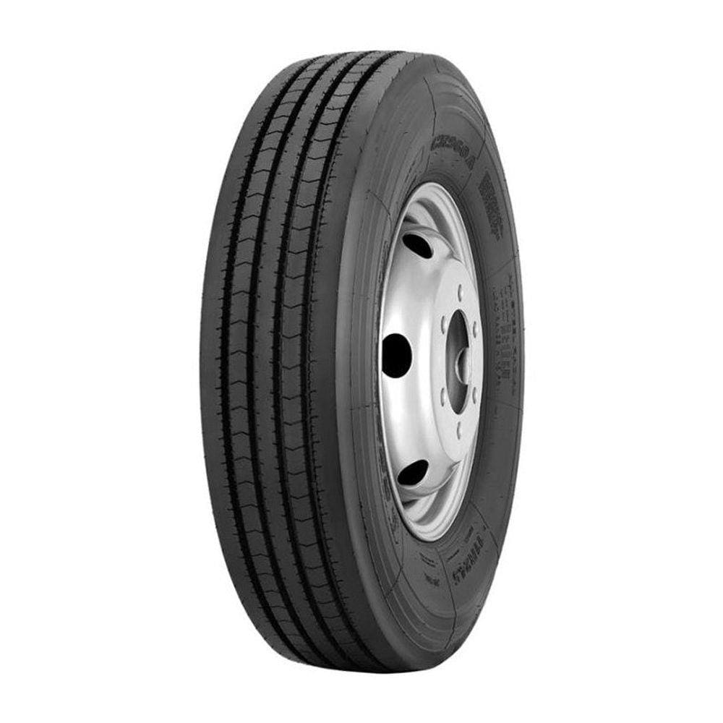

Pneu 215 75r17 5 16 lonas 135 133l bf188 blacklion

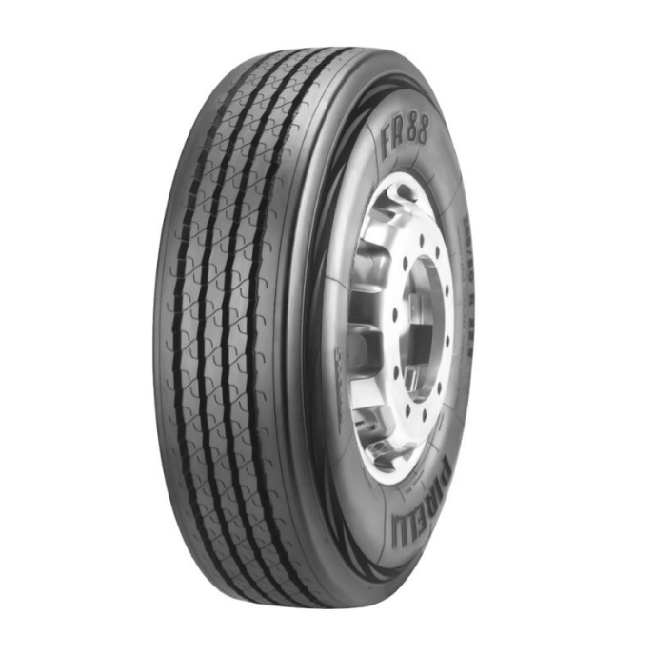

Pneu 295/80R22.5 Fr88 Pirelli

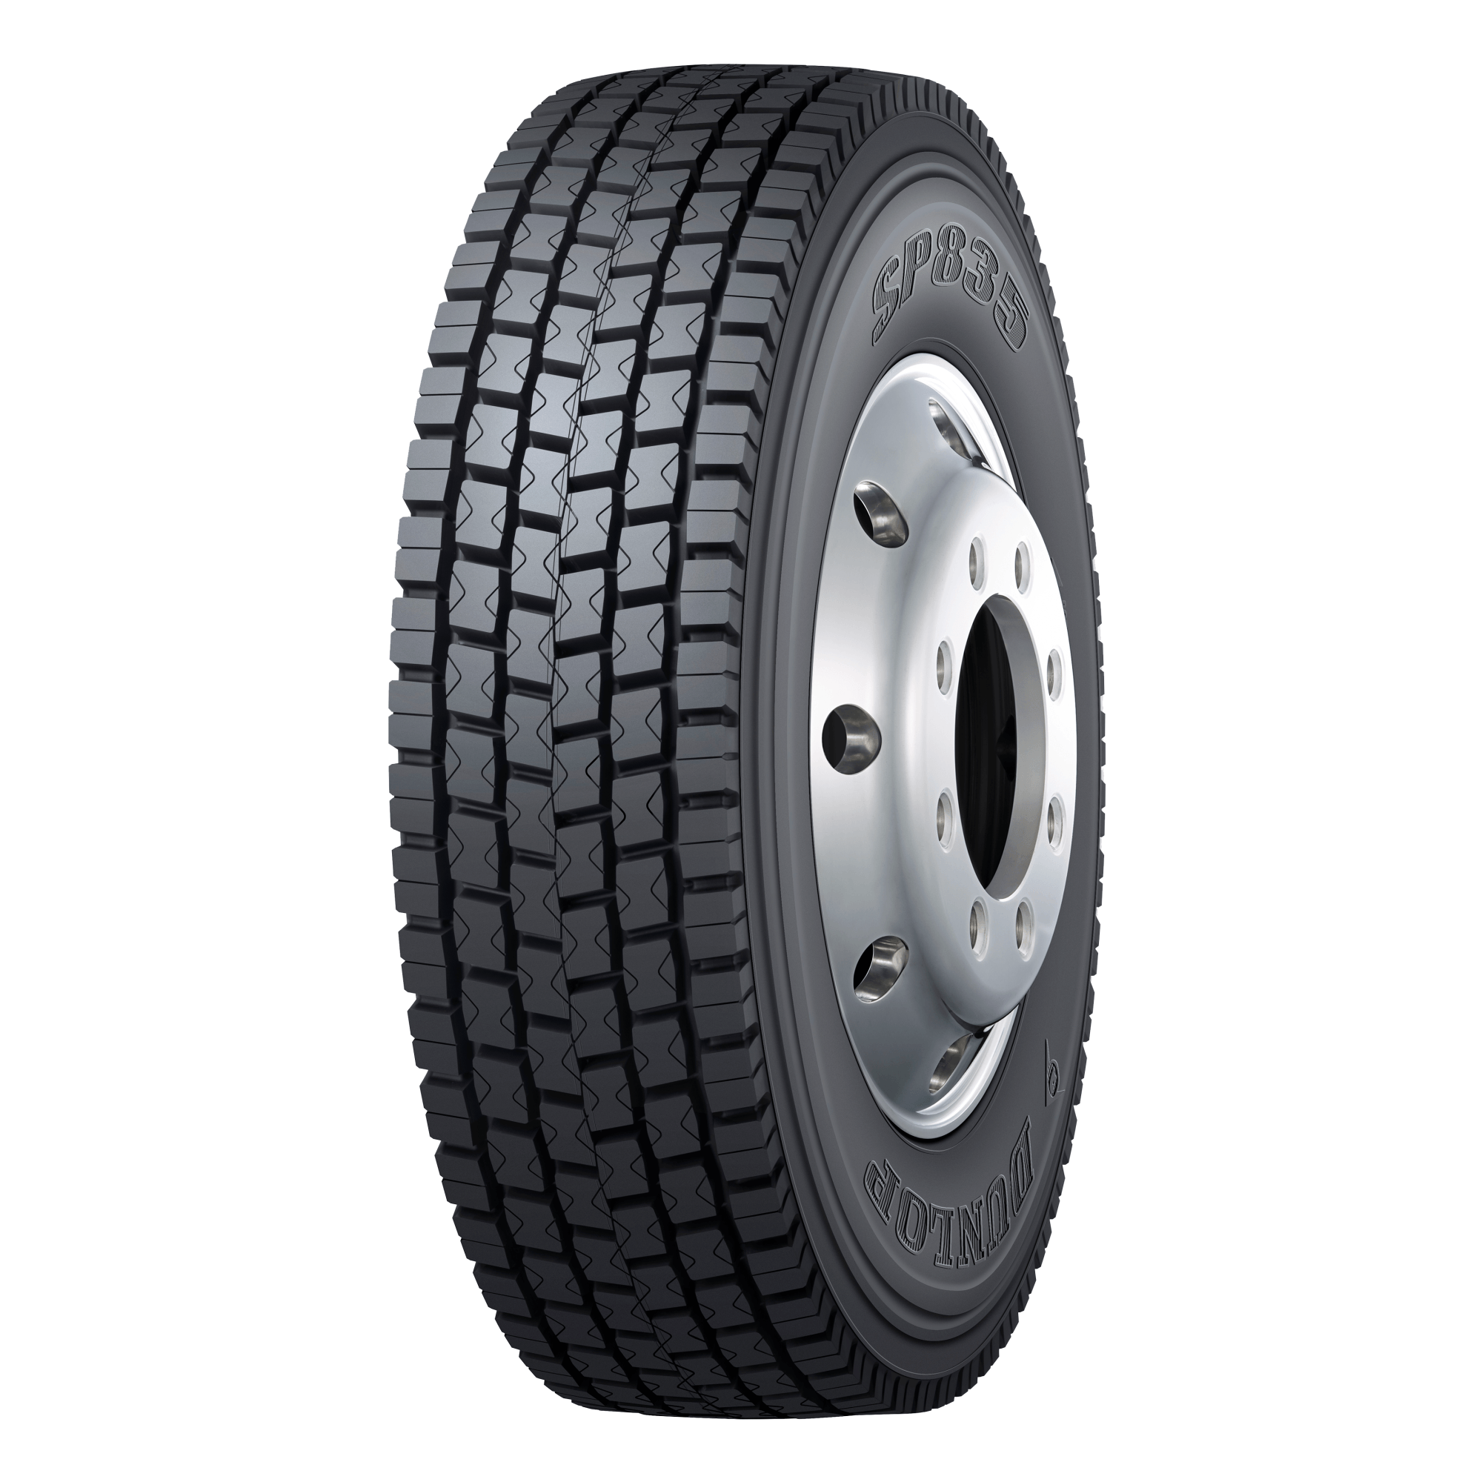

Pneu 295/80R22.5 Dunlop Sp835 152/148M

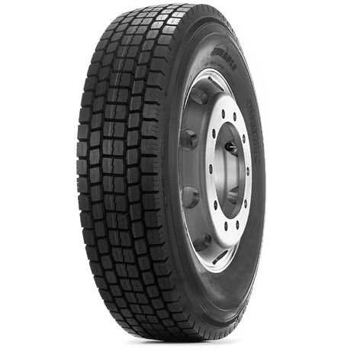

Pneu Durable Aro 22.5 295/80r22.5 18PR 152/148M DR755 Borrachudo

LINGLONG

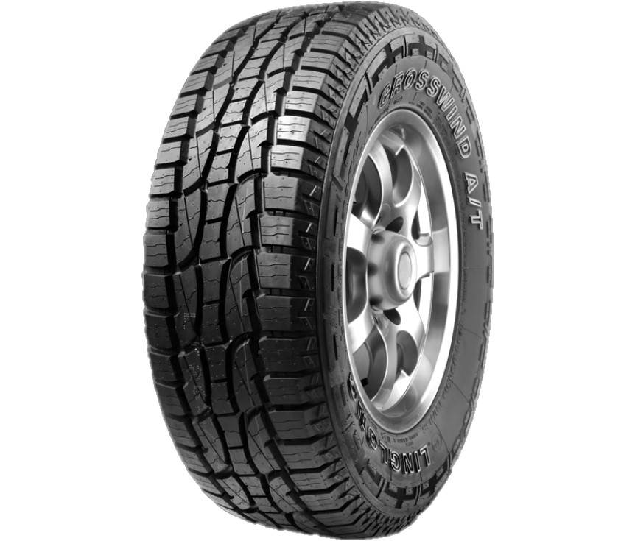

Pneu 265/70r16 Linglong Crosswind At 112t

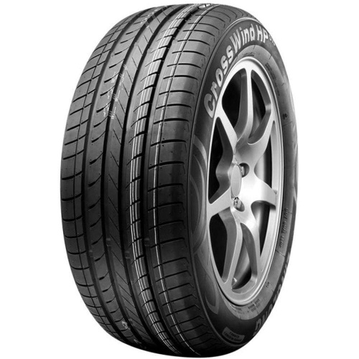

Pneu 215/60R17 96H Crosswind Hp010 Linglong

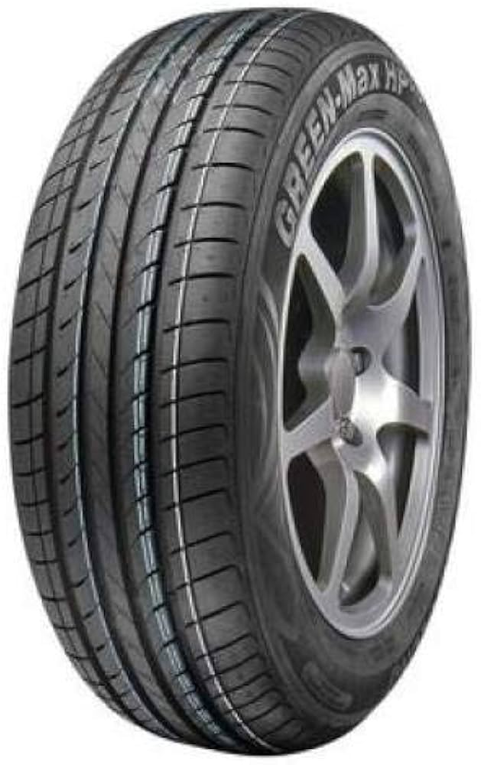

Pneu Linglong 165/50-15 Green Max

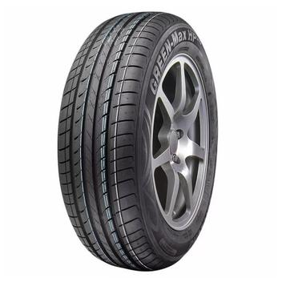

Pneu Linglong 175/60-15 Green Max



Pneu Linglong 175/65-15 Green Max HP010

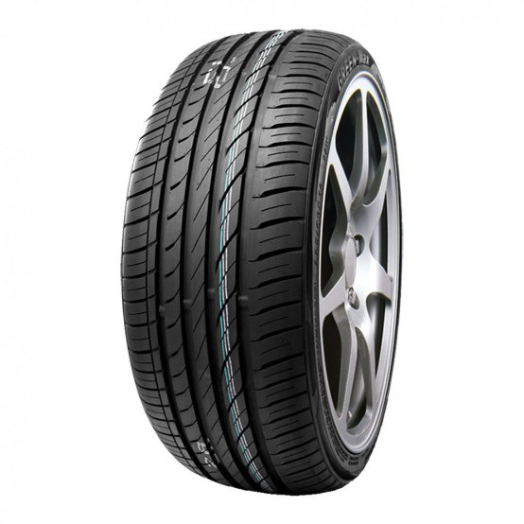

Pneu Linglong 185/45-15 Green Max

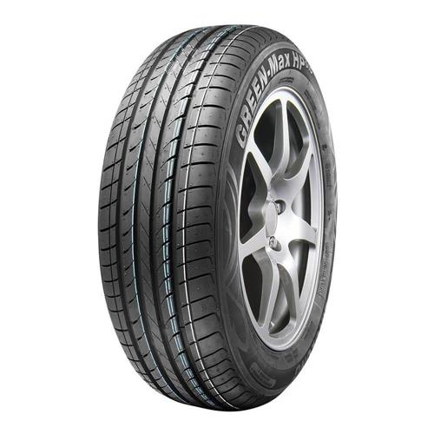

Pneu Linglong 185/55-15 Green Max HP010

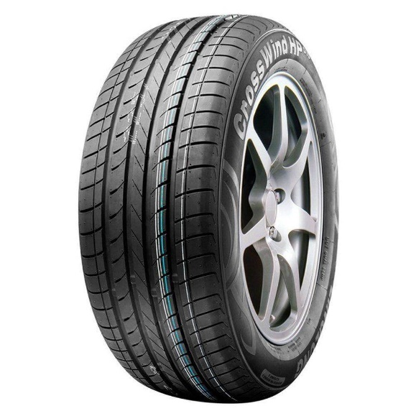

Pneu Linglong 185/60-15 Comfort/Crosswind